Project Name: LockedMe.com

Submitted By – Sunil Kumar Patra

Submission to – Simplilearn (Project -1)

Date of Submission – 6th September 2022

Git Hub repositary link : <https://github.com/patrasunil0/SimplilernPhase1Project.git>

Project Brief: This project is defined to develop a software in which the user can access the following operation by the developed software with choosing the displayed options.

* Display all availbe files inside the directory.
* Add a new file with content added to the file.
* Delete any file by name in the particular directory.
* Search availibily of any file by name in the particular directory.
* Exit from the directory.

**Concept Used to complete the Projects are:**

* Do while loop
* If else statement
* Try catch statement
* Switch statement
* Java utility Scanner and I/O File and FileWriter has been used.
* Searching and sorting

**Flow Chart of the Software**

File not found

Display all

Yes

Folder Empty

No

1

Welcome Screen

1. Display all Files
2. Add a File to existing Directory
3. Search a File
4. Delete a File
5. Exit

No

**Enter**

File Name

**Enter**

File Name

Line Length & Content

3 3 2

Yes

File Available

Yes

4

**Enter**

File Name

5

File not found

File Created

End

No

Yes

File Deleted

**Source code with two sprint has been taken to complete the Project.**

1. **First source code is clientApp (Fornt-end coding)**

|  |
| --- |
| 1.package lockedMe.com;   1. import java.util.Scanner; 2. public class ClinetApp { 3. public static void main(String[] args) {  6. Scanner obj = new Scanner(System.in); 7. int ch; 8. do 9. { 10. LockedMe.displayMenu(); 11. System.out.println("Enter Your Choice: "); 12. ch = Integer.parseInt(obj.nextLine()); 14. switch(ch) 15. { 16. case 1:LockedMe.getAllFiles(); 17. break; 18. case 2:LockedMe.creatFiles(); 19. break; 20. case 3:LockedMe.deleteFiles(); 21. break; 22. case 4:LockedMe.searchFiles(); 23. break; 24. case 5:System.out.println("\"Thank you\" Visit Again !!!!!"); 25. System.exit(0); 26. break; 27. default:System.out.println("Invalid option"); 28. break; 29. } 31. } 32. while(ch>0); 33. obj.next(); 34. obj.close(); 36. } 37. } |

**2. Second Source code (Backend coding)**

|  |
| --- |
| 1. package lockedMe.com; 2. import java.io.File; 3. import java.io.FileWriter; 4. import java.util.Scanner; 5. public class LockedMe { 7. static final String projectFilesPath = "D:\\JAVA\\SimpliLearn\\Project\\Submission\\LockedMeFile"; 8. public static void displayMenu() 9. { 10. System.out.println("*********************************************"); 11. System.out.println("\tWelcome to LockedMe.com Secure App"); 12. System.out.println("\tDeveloped by Sunil Kumar Patra"); 13. System.out.println("*********************************************"); 14. System.out.println("\t\t1. Display all Files"); 15. System.out.println("\t\t2. Add files to the existing directory list"); 16. System.out.println("\t\t3. Delete a File"); 17. System.out.println("\t\t4. Searche a File"); 18. System.out.println("\t\t5. Exit"); 19. } 20. public static void getAllFiles() 21. { 22. File folder = new File(projectFilesPath); 23. File [] listOfFile = folder.listFiles(); 25. if (listOfFile.length>0) 26. { 27. System.out.println("File lists are displayed below"); 28. for(var l:listOfFile) 29. { 30. System.out.println(l.getName()); 31. } 32. } 33. else 34. { 35. System.out.println("The Folder is Empty"); 36. } 37. } 38. public static void creatFiles() 39. { 40. try 41. { 42. Scanner obj = new Scanner(System.in); 43. String fileName; 44. System.out.println("Enter the File Name: "); 45. fileName = obj.nextLine(); 47. int linesCount; 48. System.out.println("Enter How many Lines you want to Enter : "); 49. linesCount = Integer.parseInt(obj.nextLine()); 51. FileWriter fw = new FileWriter (projectFilesPath+ "\\"+fileName); 52. for(int i=1;i<=linesCount;i++) 53. { 54. System.out.println("Enter the File Line: "); 55. fw.write(obj.nextLine()+"\n"); 56. } 57. System.out.println("File Create Successfully"); 58. fw.close(); 60. } 61. catch (Exception e) 62. { 64. } 66. } 67. public static void deleteFiles() 68. { 70. Scanner obj = new Scanner(System.in); 71. String fileName; 72. System.out.println("Enter the File Name: "); 73. fileName = obj.nextLine(); 74. File f = new File(projectFilesPath+"\\"+fileName); 75. if(f.exists()) 76. { 77. f.delete(); 78. System.out.println("File successfully deleted"); 79. } 80. else 81. { 82. System.out.println("File not found"); 83. } 85. } 86. public static void searchFiles() 87. { 88. Scanner obj = new Scanner(System.in); 89. String fileName; 90. System.out.println("Enter the File Name: "); 91. fileName = obj.nextLine(); 92. File f = new File (projectFilesPath+"\\"+fileName); 93. if (f.exists()) 94. { 95. System.out.println("The File is available"); 96. } 97. else 98. { 99. System.out.println("File not found"); 100. } 101. } 103. } |
|  |

**Screenshot of every prototype added to the software.**

1. 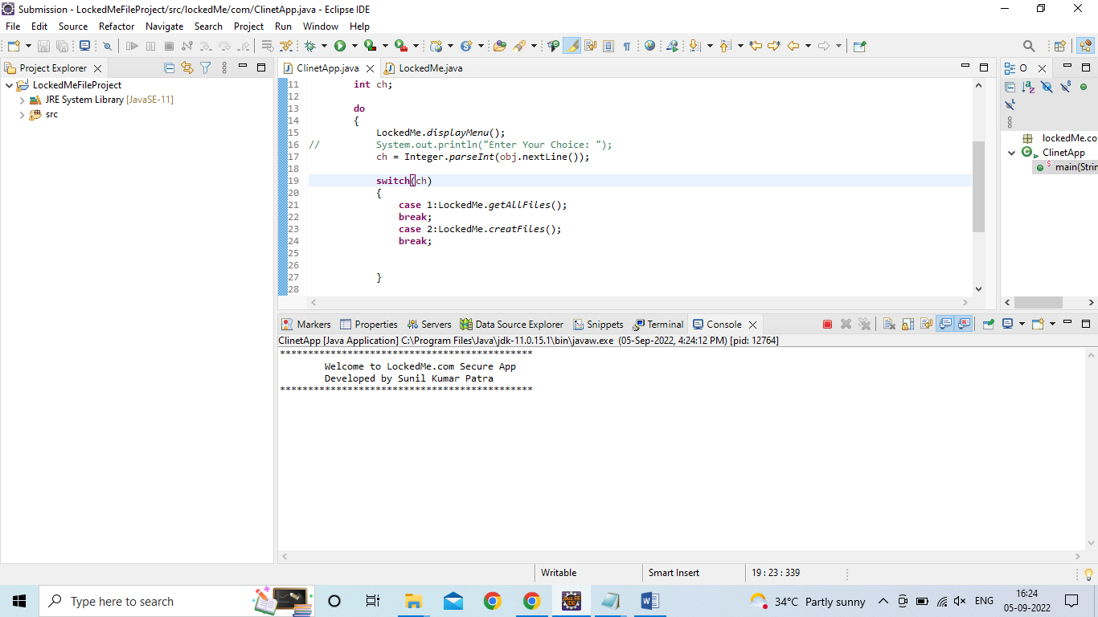**Welcome Screen.**
2. 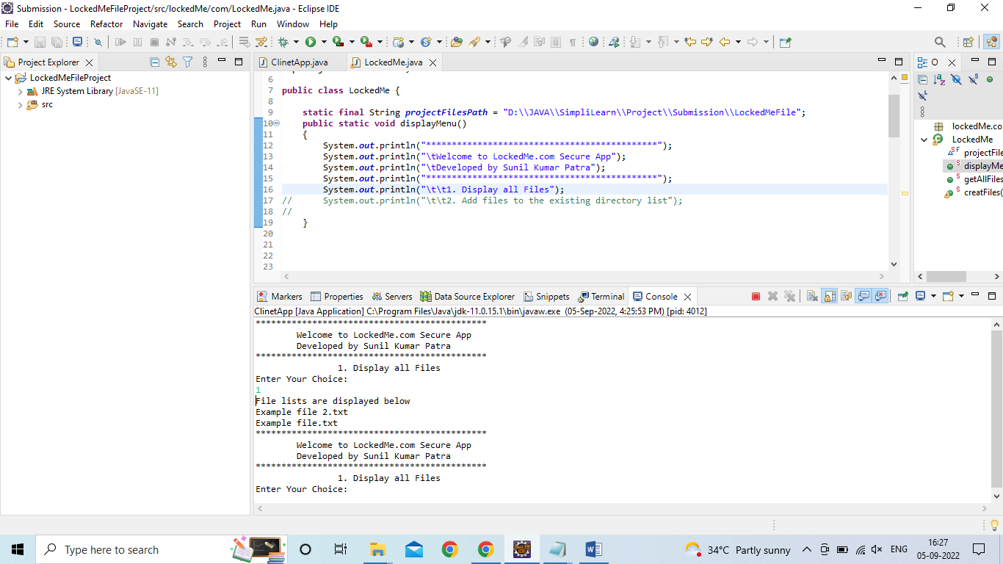**Display all available Files**
3. 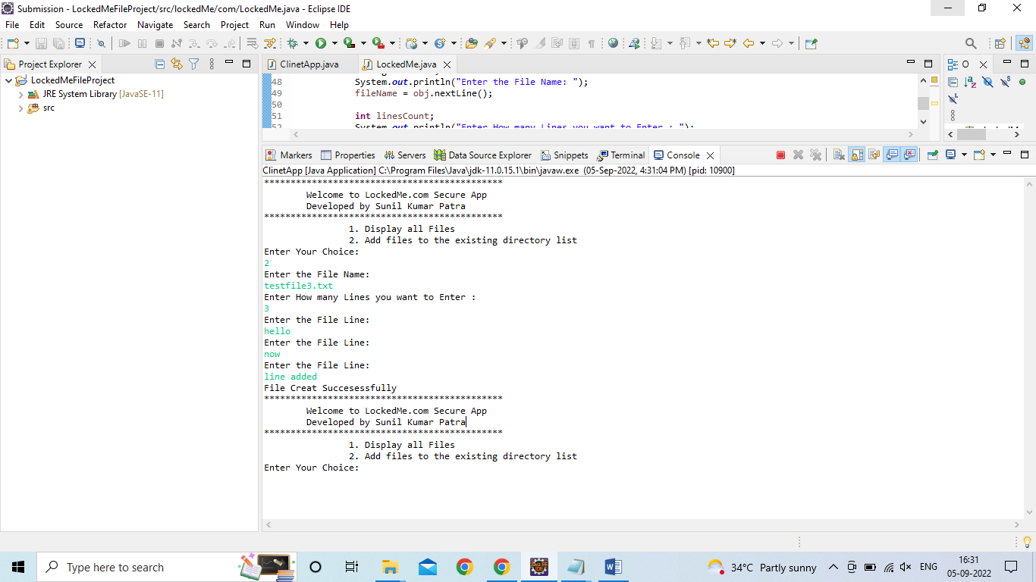**Add a File to existing directory list**
4. **Delete a File**

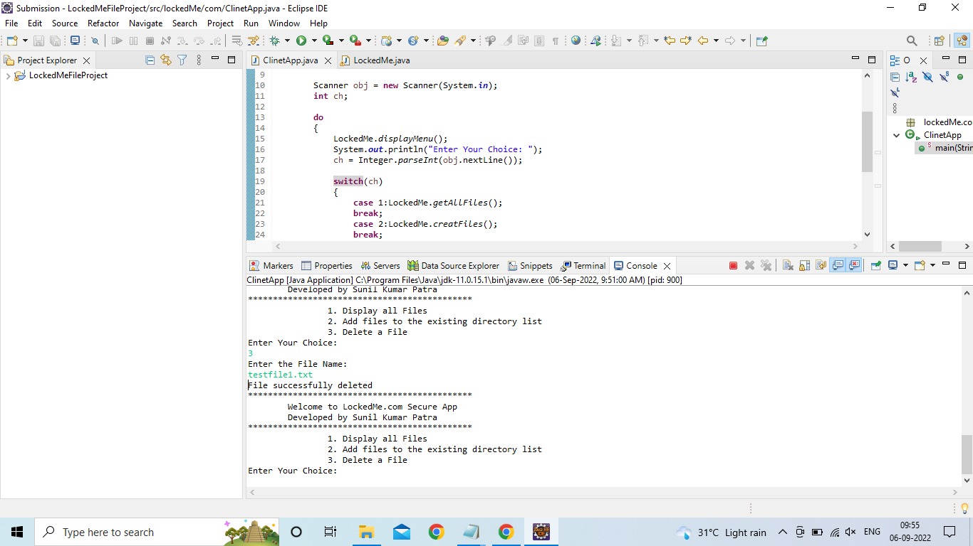

1. 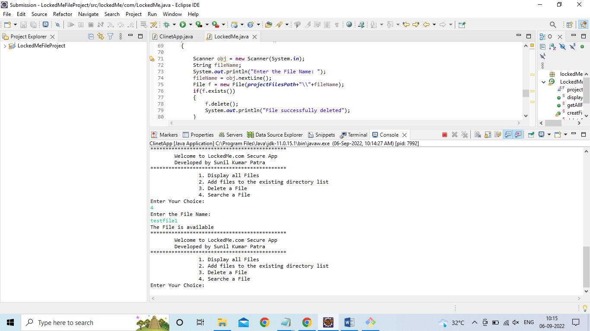**Search a File**
2. 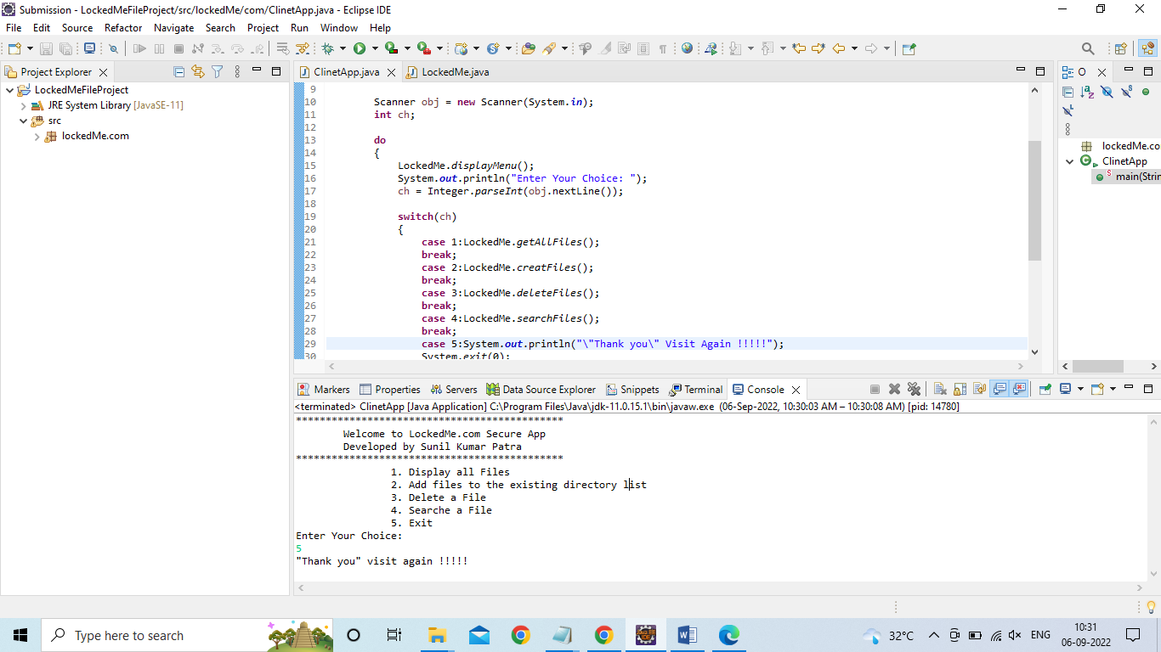**Exit**

**Thank You !!!!!**

**Project report prepare by Sunil Kumar Patra**

**Submission – Project 1_ Phase 1_ Simplilearn**